Verify Check  Cleanliness  Seat condition OK  Operator restraint provided  Instruments operational & labeled  Levers / controls operational  Pedals in good condition  ROPS to AS 2294  Windows / wipers / washers  Rear view mirrors  Operator instruction  (available on plant)  Cab  Warning devices  Verify Check  Horn  Reversing alarm  Verify Check  Warning signs (in cabin)  SEAT BELTS MUST BE WORN  Verify Check | Supplier verification & plant details
 | Plant owner:
 | Address:
 | City/Suburb:
DANGER – SAFE WORKING LIMITS ON BATTERS  Ratio 4 to 1  example only. As per manufacturer’s specification  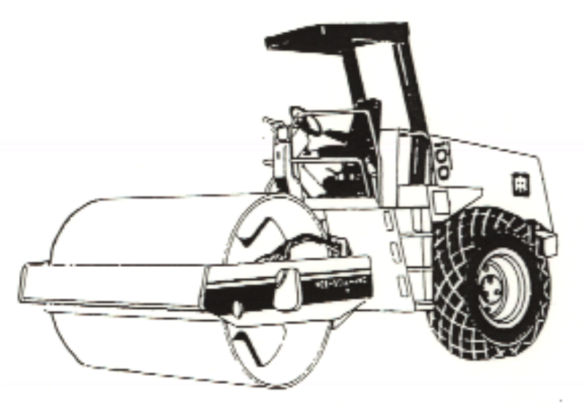 | Phone:
 | Plant make:
Verify Check  Locating lock for  Low/Neutral/Lower range  Padlock provided  Warning sign –  “Hasp must be locked in position  before operating”. | Plant model:
Verify Check  Exhaust | Serial no.:
 | Signature:
 | Date:
L N H  Verify Check  Engine guarding | Statement of operator competence required
Verify Check  Tyres  Wheels  Brakes  Park brake |  Plant to conform to manufacturer’s specifications and Plant Regulations.   Plant operator is to provide daily checksheets to WDA on a weekly basis.   Where applicable, Personal Protective Equipment must be worn.   Plant Log Book detailing service history in accordance with Manufacturer’s specifications should be written legibly in English.   Contractor must produce proof of competence of operator, e.g., Certificate of Competence, Licence, detailed Log Book
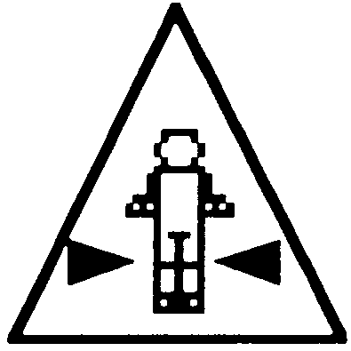  Verify Check  Hoses  Connections  (check for excessive wear,  leaks and creep)  Hydraulics  Verify Check  Crush point hazard  sign displayed both sides  Verify Check  Handrails  Steps | WDA use only
 | Note: Sign only when all items have been checked
 | Plant check by:
Instructions:  Verify Box to be ticked by Owner / Supplier / Operator prior to arrival onsite.  Check Box to be ticked after visual inspection by WDA | Position:
 | Date: |  | / /

